Week 7 KERNELS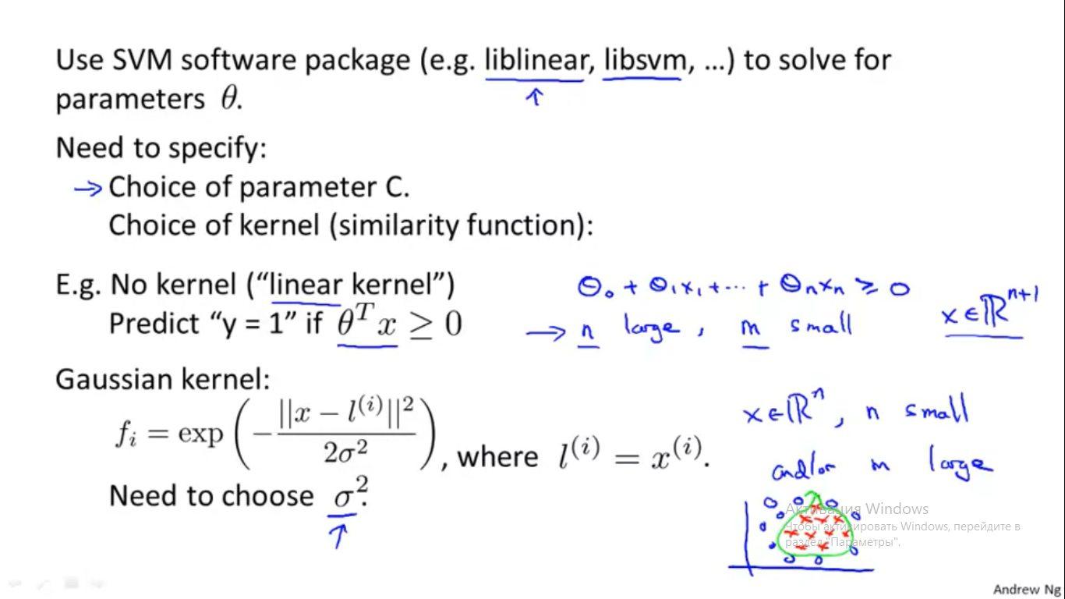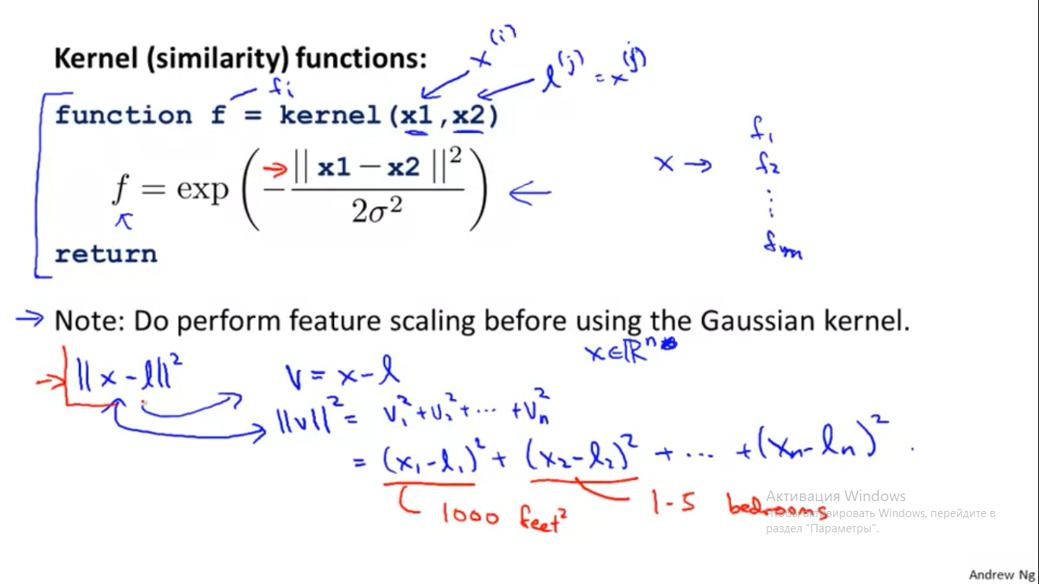

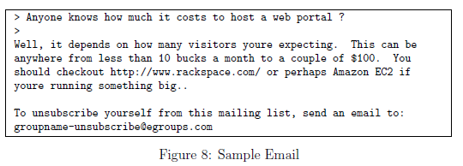

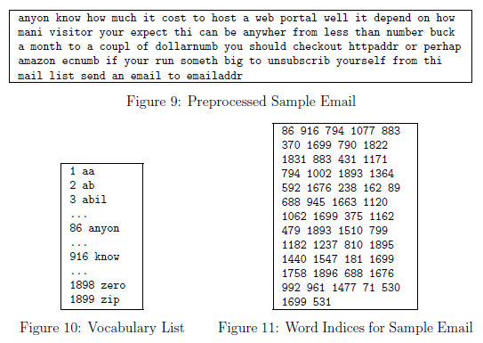

Week 8

Principal Component Analysis Algorithm

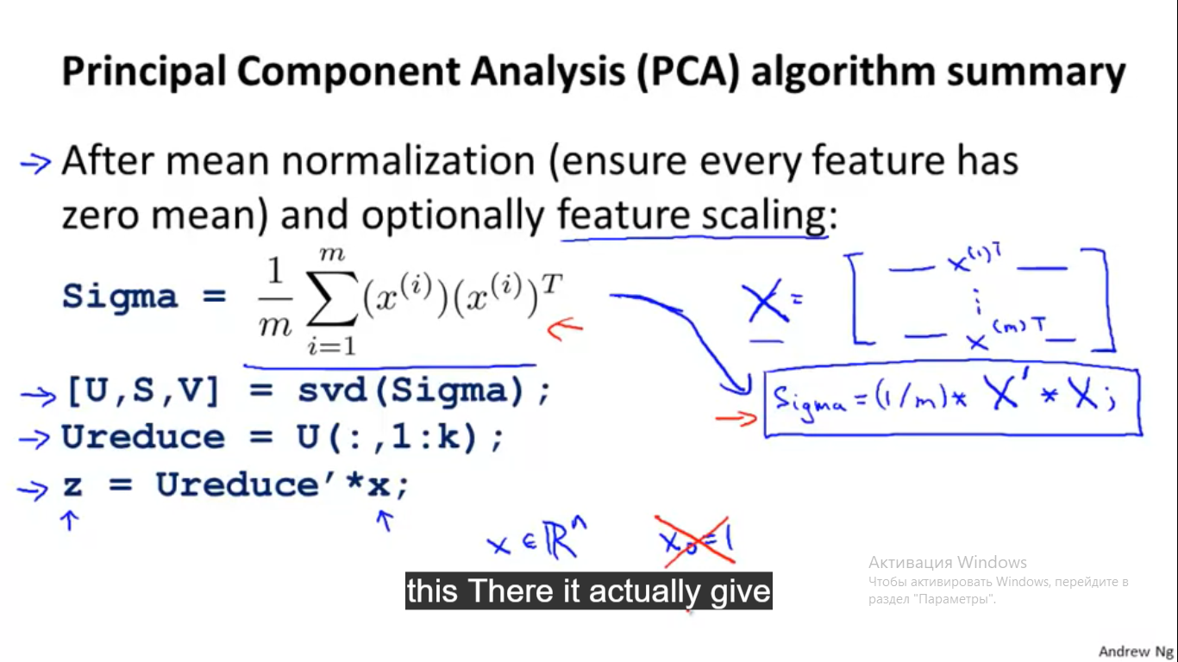

Advice for applying PCA

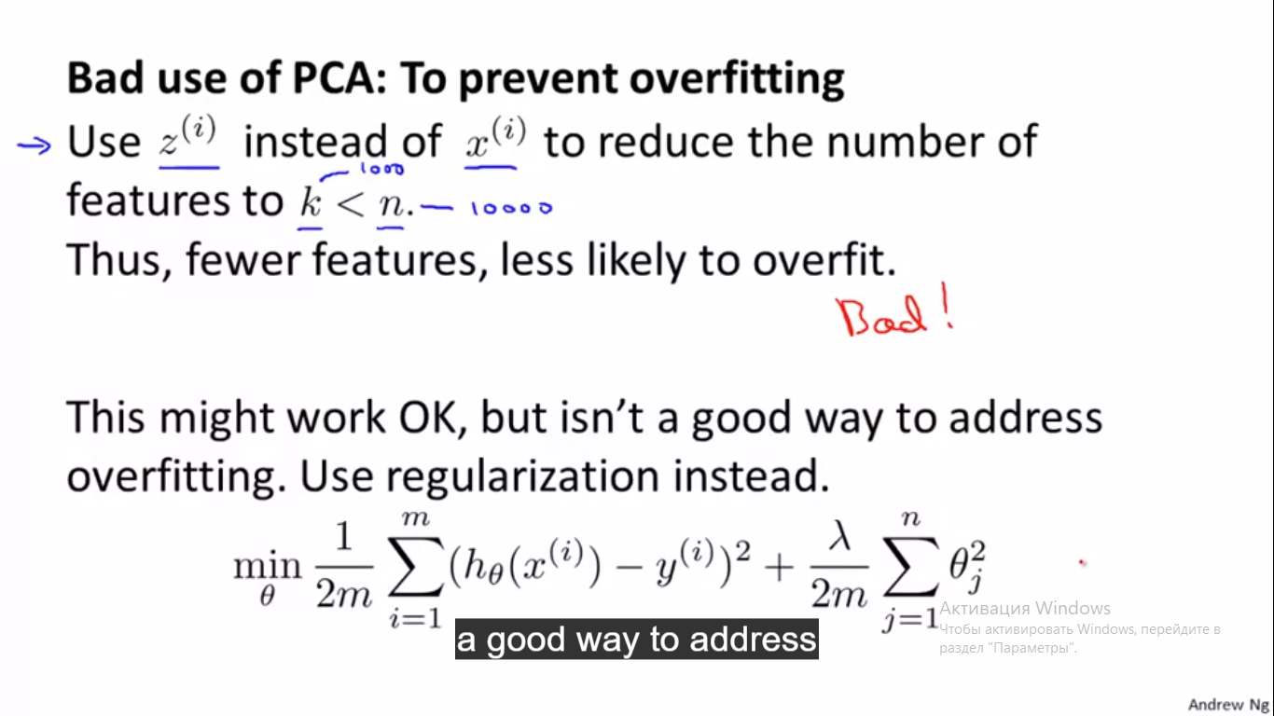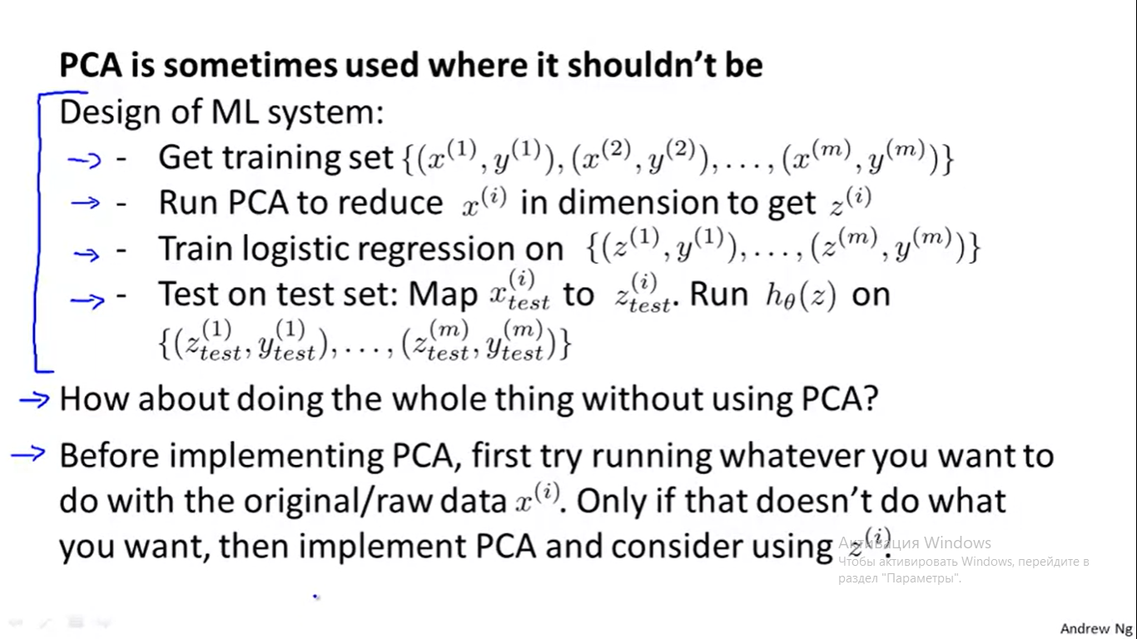

Ссылки на код ex.4 Neural Networks

<https://github.com/everpeace/ml-class-assignments/blob/master/ex4.Neural_Network_Learning/mlclass-ex4/nnCostFunction.m>

<https://github.com/bsmithgall/coursera-ml/blob/master/ex4-003/mlclass-ex4/nnCostFunction.m>

<http://read.pudn.com/downloads421/sourcecode/math/1783681/mclassex4/nnCostFunction.m__.htm>

<https://iotmakerblog.wordpress.com/2016/06/28/04-octave-programming-neural-network-learning/>

<https://github.com/DragonflyStats/Coursera-ML/blob/master/Week-06/Quiznotes.tex>

Week 9

Anomaly Detection Algorithm